Site Visit was conducted by Mr. Sok Ratanak, Mr. Chiv Hak
Dated on 11-06-2018

Map: Collateral (To be purchased)
Address: A105-402 (4th floor), Phum Toul Kork, Sangkat Toul Sangke, Khan Russey Keo, Phnom Penh

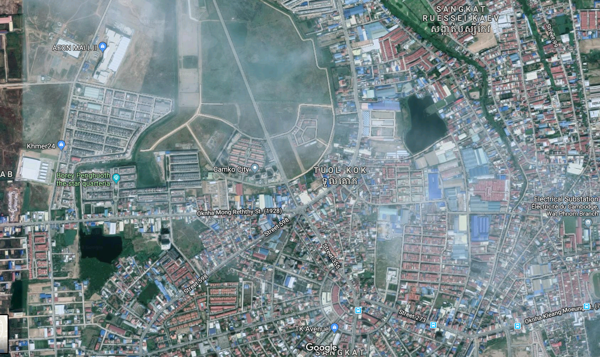

Condominium
(4th Floor- Camko City)

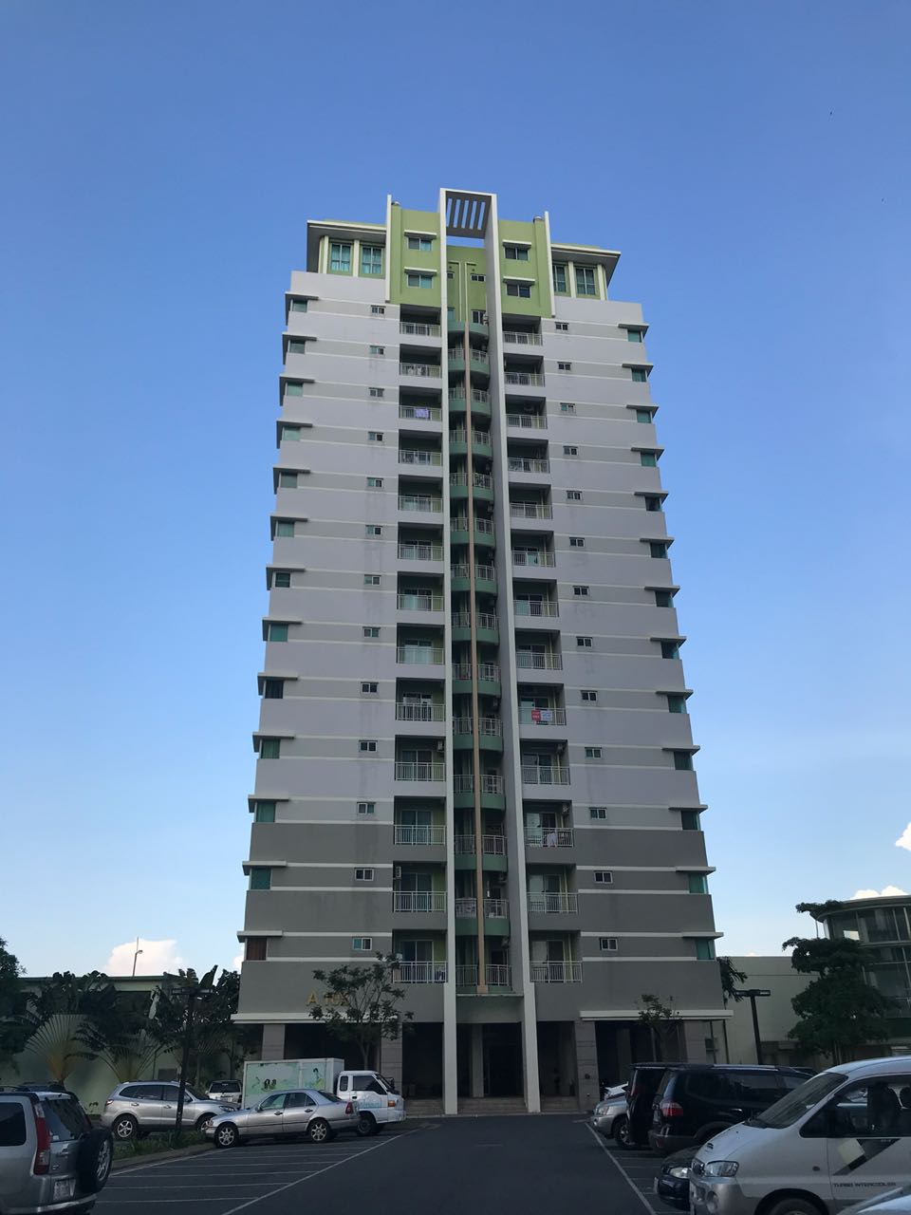
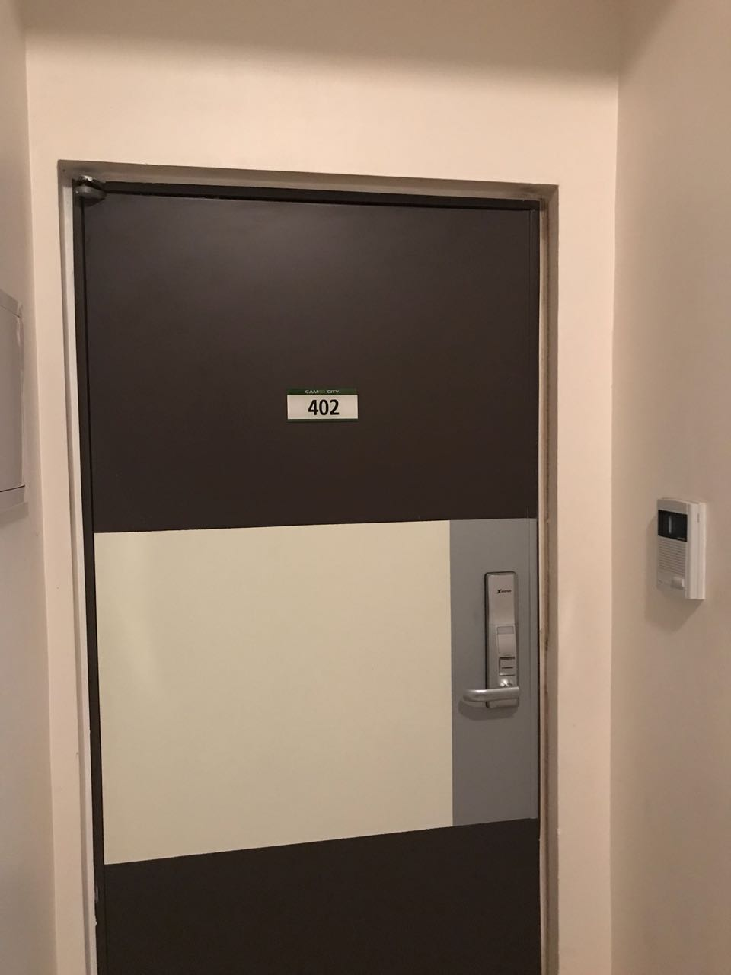

Collateral (To be purchased)
Address: A105-402 (4th floor), Phum Toul Kork, Sangkat Toul Sangke, Khan Russey Keo, Phnom Penh

